Vyacheslav Ivanov
30 may 1985
Live in Moscow Russia
Contact information:
+7(926) 187-4535
viacheslavivanov@yandex.ru
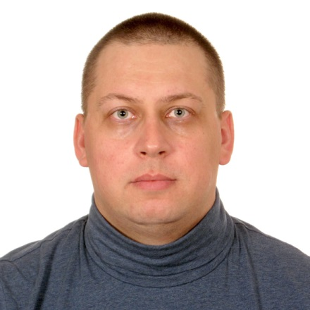

Working Experience.
January 2011 – until now Intelis LLC (v-or.ru)
Key account manager

- Responsible for the development and operation of corporate direction;
- no network clients;
- Implementation of Windows for SUVs in the B2B channel (UAZ, Niva, sable);
- Work with corporate (permanent) customers (retail and wholesale stores, service stations) ;
- Identification of needs;
- Planning of sales;
- Project negotiations, analysis of sales;
- Search for new corporate clients (personal meetings, specialized forums (Uazbuka, drive), social networks);
- Ordering of goods under the client project, control from order to receipt;
- Purchasing, logistics, orders, reporting, movement order;
- Procurement (about 50 SKY);
- 10% of the operational tasks;
- Placement of advertising materials in the Internet (thematic sites, forums);
- Website creation to promote and unify the order.
- Participation in developmen.

August 2008 - February 2010 гг. OTIS (Otis.com)
Manager contract compliance
- The activities of the Treasury of the company regarding contract compliance;
- Conducting telephone conversations, visits to contractors, preparation of plan of measures on repayment of debts on contracts;
- Development of report templates in Excel;
- List generation and mailing of letters, claims, statements project statement, debtors;
- Restructuring, Bank guarantees, letters of guarantee, amendment to the financial terms of contracts, negotiation of additional agreements;
- Organization of the work group on collection of receivables;
- Organization of work of the responsible employees of the regional network;
- Control of work of employees of the regional network (meetings, reporting);
- Reporting to higher management about the work done;
- Interaction with adjacent departments of the company;
- Working closely with accounting to close month;
- Daily monitoring of cash flow, pay bills;
- Coordination of invoicing of problematic contracts;
- Drafting of the action plan on problem contracts;
- Approval of changes to the timing, methods and terms of payment on problem contracts;
- Approval of debt relief on the expiry of the limitation period;
- The compilation and maintenance of list of TOP 10 debtors;
- Identifying and developing stages of interaction with the TOP 10 debtors;
- In certain situations, restoring, copying, coordination of full package of documents on problem contracts;
- The planning figures for the period, preparing the materials about the status of accounts receivable;
- Development of anti-crisis measures on reduction of losses;
- Civil proceedings (together with legal Department)
March 2007 – May 2008 MDMBank LLC (MDMBank.ru)
Chief specialist
- Debt collection up to 90 days;
- The group's management of debt collection in the amount of 20 people;
- Payments control;
- Interaction with adjacent departments;
- Control of work of employees of Bank branches in the area of debt collection;
- Training of employees in methods of work;
- Monitoring employees in terms of conducting telephone negotiations;
- The evaluation of the unit;
- Working with statistics;
- Creating a schedule;
- Calculation of awards by results of work for the period;
- 10,000 customers a week at work;
- Reporting on the work done.
January 2006 -March 2007 MDMBank LLC
Call center specialist

- Handling incoming calls;
- Advising clients of the Bank issues plastic cards;
- Advising clients of the Bank and third parties regarding services of the Bank;
- Registration of actions in the system;
- Performing duties of shift supervisor when night work;
- Interaction with adjacent units;
- Decision of disputes;
- Accepting applications about unlock cards, blocking cards ATM, BCS;
- Compliance with the Bank policy on dealing with customers.

Education.
Moscow city psychological and pedagogical University. (MGPPU.ru)
Higher. Full-time. Social psychologist qualification. Diploma 2002 – 2007 years.

Key skills.
Computer skills at user level. (Internet, Office applications, office Equipment)
Driving license cat. B (10 + years)

For more information.
In marriage do not consist.
Children do not have.
Bad habits no. Active in sports (powerlifting)

