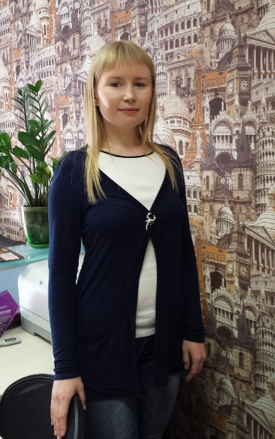
Marina Nazarchuk
Telmana street, 43A-12, Krasnoyarsk City, Russian Federation
tel. +7-902-965-31-94, +7-925-304-31-29
marintour83@yandex.ru
Objective | Flight Attendant
Personal Details | Date of birth: 16th of November 1983  Marital status: not married  Sex: female
Summary of Qualifications | High-experienced in customer communication and service, accurate, assertive and adaptable manager who can effectively multi-task in challenging situations and meet critical deadlines.
Education | 2001 – 2004 Krasnoyarsk Technological College. Manager.  Tourism and hospitality. Organization of service in hotels and tourist complexes.
Additional Education | 1998 – 2001 East-Siberian Institute of Tourism.  Course of English.
Professional Experience | Sept.2012 – current Premier LTD. General director.
 | Organization and management of the office. Consulting and implementation of tourist products, contracts with customers. Search for partners, negotiations, contracts for the provision of tourism services providers. Reservation and registration of railway, airline tickets, hotels. Drawing up the menu and catering services for children and adult groups. Organization and control of the company by domestic tourism (organization of children's sports activities for summer and winter sports). Supported groups of children to rest and recreation in Sochi (railway), St. Petersburg (air).
 | April 2008 – Sept .2012 SV.Maslova LTD
 | Receiving calls and consulting clients on the phone and in the office. Selection of tours, registration of the transaction, the conclusion of the contract. Quality control of services and subsequent support customers. Organization of group of children's tours in Russia and European countries. Visa support. Admission to Krasnoyarsk (reservations, arrange transportation, tours, meals).Search for partners, negotiations, contracts for the provision of tourism services providers. Maintenance Agency reports. Development of advertising models. Guide exhibition activity of the company. Brand promotion in the Internet. Successful execution of public contracts for municipal needs. Reservation and registration of railway, airline tickets, hotels, transfers. Drawing up the menu and catering services for children and adult groups. Receiving international visitors in Krasnoyarsk (accommodation, food, transport and excursion maintenance, organizing and conducting children's sports activities for summer and winter sports).
Professional Experience | Sept. 2005 – Feb. 2008 Yenisey-Tour LTD
 | Receiving calls and consulting clients on the phone and in the office (tours in Russia and CIS countries). Selection of tours, registration of the transaction, the conclusion of the contracts. Quality control of services and subsequent support customers. Maintenance Agency reports. Organization of group of children's tours in Russia and European countries. Visa support. Admission to Krasnoyarsk (reservations, arrange transportation, tours, meals). Maintenance of children's group rail in St. Petersburg. Development of models of advertising production company. Participation in exhibitions.
Key Skills | Client satisfaction, stress resistance, responsibility, no bad habits, multi-task management, optimism, ability and desire to learn.
Accomplishments | Collaborated with departments and clients to ensure the delivery of efficient, high-quality service. Consistently recognized by management for providing superior customer service.)  I have registered letters of thanks for the successful organization of leisure, recreation and spa treatment of students of Siberian Federal University in 2010 and 2011.)
Interests | I lead a healthy lifestyle. Hobbies: foreign languages, traveling, photography, walking outdoors, Chinese cuisine, football. I have a driving license category B. Advanced PC user. I have a valid B1 visa to the United States till 19/11/2016 and the Schengen (France) till 21/12/2015.
Languages | Russian – native  English - enough for interview, fluent  German - basic knowledge  Turkish - basic knowledge, but fluent

