**Name: TYMUR TSAPCHUK**   
Address: 2935 N 75th Ct, Elmwood Park, IL 60707, USA Phone: 1 (773) 971-5333, 1 (773) 971-8050 E-mail: timur.not1@gmail.com  
Date of birth: 25 March 1992  
Age: 23 Marital status: married  
Nationality: Ukrainian 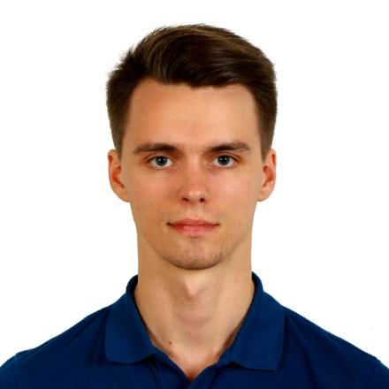  
  
**EDUCATION:**  
2011 – 2015 - State Higher Education Institution “National Mining University” – bachelor of marketing, Dnipropetrovsk, Ukraine 2011 - School of the Modern art of Service “Bar&Service” has completed the course “Bartender” According to international Bartenders Association method / IBA, Dnipropetrovsk, Ukraine December 2011, master Class of “demonstration of classic style of work bartender for international competitions, halls, hotels and restaurants of higher level of service to high-ranking persons”, Dnipropetrovsk, Ukraine September 2011, master Class of master “lab cocktails”, Dnipropetrovsk, Ukraine August 2011, master Class of “cocktails decoration”, Dnipropetrovsk, Ukraine

**WORK EXPERIENCE:**  March 2014 – June 2015 cafe&restaurant “1916”, bartender, Dnipropetrovsk, Ukraine March 2013 – January 2014 restaurant “Reporter”, waiter, Dnipropetrovsk, Ukraine September 2012 - coffee house and restaurant “DaVinci”, bartender, Dnipropetrovsk, Ukraine October 2011 – July 2012 - cafe and lounge bar "Nargile”, bartender, Dnipropetrovsk, Ukraine and Night Club “Moulin rouge”, bartender, Dnipropetrovsk, Ukraine Summer 2010 – summer 2011, shop "Levis", seller, Dnipropetrovsk, Ukraine  
  
**LANGUAGES:** Russian – fluentEnglish – advanced

**OTHER SKILLS OCCUPATIONS:**  
Experience of computing: MS Office (Word, Excel), Power Point, Internet Explorer.

**HOBBIES AND INTERESTS:**  
Sports (football, tennis, skiing, billiard, swimming), dancing, go camping, go cinema, listening to music

**PROFESSIONAL SKILS:**  
Communicative, active, hard - working  
  
**PERSONAL QUALITIES:**  
Sociable, hardworking, responsible, punctual, accurate, cheerful, sympathetic, enduring, easy to get alone with,  have good organizational skills, sense of humor, mobility, creativity, good driver.