Name: Iryna Velizhanina  DOB: March 27, 1978  Place of birth: Kherson, Ukraine  e-mail: iryna270378@yandex.com  phone: +13237946339 | 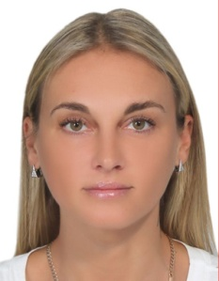
EDUCATION:
2005 | - | Baltic State Technical University, International Industrial Management

JOB EXPERIENCE
Date | Job title | Responsibilities
09/2013 – 08/2015 | Director general, Bar 21 Co., Ltd (Pattaya, Thailand) | Director of the restaurant, creating a menu, food control, human resources planning, cooking, food serving, organizing of the business from the beginning.
03/2012 – 08/2015 | Sales manager, MyThai Home Co., Ltd (Pattaya, Thailand) | Selling real estate, preparing contracts, presenting projects, real estate management for lease purposes
02/2011 – 03/2012 | Sales manager, Cozy Beach View Condominium (Pattaya, Thailand) | Selling real estate, preparing contracts, presenting projects, real estate management for lease purposes, sales analysis.
01/2010 – 02/2011 | Hotel guide, Capital tour Co., Ltd (Pattaya, Thailand) | Selling tour packages to tourists, presentation of tours, check-in check-out services, transfer organization, sales analysis
12/2008 – 01/2010 | Hotel guide, Corsa travel Co., Ltd (Pattaya, Thailand) | Selling tour packages to tourists, presentation of tours, check-in check-out services, transfer organization, sales analysis
06/2006 – 12/2008 | Director General, Buy for Less Co., Ltd (Pattaya, Thailand) | Organizing of a retail business, selling of clothing, human resources management, making contracts, organizing of promo campaigns, sales analysis.
03/2002 – 05/2006 | Logistics Manager, Tehtrans agency, LLC (St.Petersburg, Russia) | Organization of freight forwarding services including within the city and between cities, preparing contracts, attracting new customers, personnel control, human resources management

LANGUAGES
English - Good

HOBBIES
Sports, reading, movies

ADDITIONAL INFORMATION
Experienced user of computer (Office, Adobe package, Power Point), ability to work in a team, experienced manager, ability to solve internal team problems (psychology aspects), strictly aimed to reach the goal of the team, high discipline, ability to organize the work, analytical mind, easy to study.

