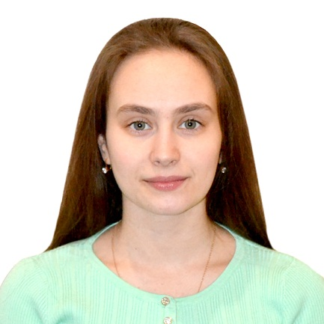  Natalya Demenkova  Server  Astana, Kazakhstan | demenkova98@bk.ru  87474014013(mobile)

SUMMARY
A polite, well spoken and hard working person. Attentively at all times with a willing and helpful manner that is required to answer phone calls, taking reservations and prepare bills. Always approachable, cheerful and possessing good observation skills as well as the ability to work alone or as part of a team.
EDUCATION
Degree
Secondary school #21, Kokshetau, Kazakhstan
2004 – 2015
Now I study on the first course at Eurasian National University in Astana, Kazakhstan. 3,85 GPA
INTERESTS
- I like sport, especially track & field
- I like new friends, I like to succeed, I like to plan fun events, I like to celebrate others accomplishments, and give people things to look forward to.
- I like to work hard and I like to be responsible with my tasks, and I like working in team.
LANGUAGES
English level - Upper-Intermediate
French level - Elementary
HIGHLIGHTS

- highly responsible and reliable
- work well under pressure
- exceptional interpersonal skills
- Extensive hospitality background
- Unbeat, outgoing and positive
- Mathematical aptitude
- Polite, clever and composed

