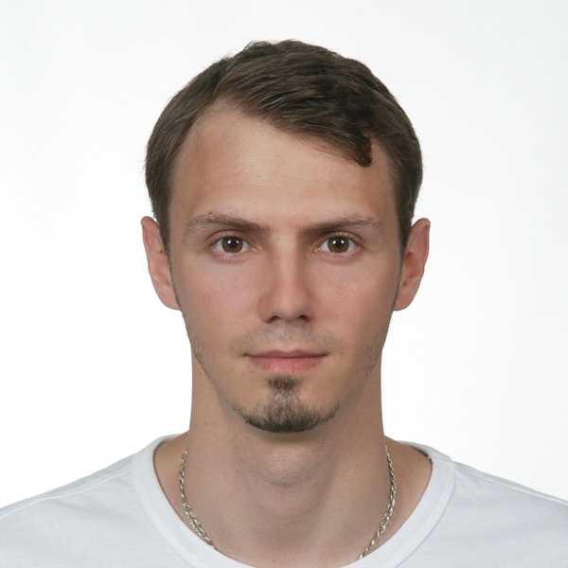
Yurii Smirnov

Date of birth: 9th of march, 1990 (25 years)
Place of birth: Ukraine, Kyiv
Nationality: Ukrainian
Place of living: United Arab Emirates, Abu Dhabi
Contact number: +97155 541 78 83
E-mail: yuriismirnov1990@gmail.com

Goals

Career objective - To get more knowledge, to accept new challenges. To get new achievements and improve me as a person. To become an expert in managing and controlling staff and company’s processes; to build very efficient team in a company. To work with trusted people with a great values to build a global project and a company on the big purpose to help people all over the world, to analyse human nature and each individual person.

Skills, competence

Computer skills - Windows, MS Office, Internet, Photoshop, Dream Weaver, network configuration, configuration of office devices (printers, IP-phones, routers, IP-cameras).
Analysis and psychoanalysis (listening, looking and gathering more information during whole day to make a truly objective conclusion about everything that is happening around), multitasking (can keep in mind different tasks while analysing information for every independent task), ability to set priorities (can manage and set priorities to each task regarding importance of each).
Responsible (was assigned as a trusted person on behalf of company to deal with contractors and staff members, to complete tasks in terms), punctual (finish all projects, missions and task on time, with a best quality), objective (not using my personal interest), fair (judge without prejudice or personal interest, only facts, laws, rules), proactive (willing to offer new ideas to company or divisions, to solve issues myself if I can without attracting extra resources, to make process in communication, manufacturing, interacting with customers more efficient and professional), communicative (easily making good relations with staff members and managers, using my psychology knowledge and social skills).

Education

Diploma with honour, specialist of Logistics Management
National Transport University - ‘Economics, management and law’ faculty
Kyiv, Ukraine
2007 to 2012

Language knowledge

Ukrainian – mother language
English – advanced
Russian – mother language

Working expirience

Waiter
Asia De Cuba – restaurant, represents the perfect culinary marriage of Asian and Latin flavors and techniques.
Nation Riviera, Corniche Road. Abu Dhabi, UAE
November 2014 to Present
Responsibilities
Delivering food from a kitchen to guests, explaining dished and ingredients, polishing plates, taking care about glassware and chinaware, controlling napkins income and outcome, cleaning and setting up tables, serving tables, guiding guest through a menu, helping managers to teach and control staff.
Accomplishments
Improved leadership skills, got more knowledge about hospitality and work in a restaurant. Started as a food runner, after 6 months was promoted to back waiter because of dedicated and hard work, responsibility, fast education. In April our restaurant won an award ‘Best new nightspot 2015’. In may our chef chief and team won an award ‘Best Young Chief 2015’. In October 2015 we won an award WHAT’S ON, ‘BEST ABU DHABI BRUNCH’ TimeOut, and ‘INNOVATIVE CHEF OF 2015’.

Chief Operating Officer
LTD 'NSK UKRAINE' – Insurance broker, provides unparalleled customer experience and service.
Kyiv, Ukraine
May 2013 to September 2014 (16 months)
Responsibilities
Made a business plan, searched for clients, improved company image, administrated the website and office, worked with clients, delivered the product to customers, generated advertising ideas, conducted interviews with potential candidates for the posts, set up local and internet network, configured printers and IP-cameras, routers, repeaters etc, installed software on PC and other devices.
Accomplishments
Improved leadership skills, improved skills as a manager, got more knowledge about insurance, got more knowledge about electronic devices. Successfully signed an agreement with 3 biggest in Ukraine insurance companies for providing unique prices for insurance products. Created a user-friendly design for a website, generated ideas about functions of the site and simple usage by customers that were released after. Launched a successful promotion company.
Because of war with Russia and fall of Ukrainian economics I had to start looking for any job beyond the border of my country.

System administrator
LTD 'FREENET' – TOP3 Internet provider on the territory of Ukraine.
Kyiv, Ukraine
June 2008 to June 2009 (12 months)
Responsibilities
Helped customers to solve issues with devices and internet services remotely, installed and reinstalled software on office computers and computers of customers, configured printers and routers, set up a network.
Accomplishments
Got a knowledge about information technologies and experience of communication with customers. Got an offer for promotion but had to resign to pay more attention to my education.

FREELANCER – web designer, HTML crafter
'Web Design FireTrot Studio' – small group of extra creative designers and programmers.
Kyiv, Ukraine
2007 to 2014 (8 years)
Responsibilities
Drew designs for sites, designs for advertisement, posters, business cards etc. Created site’s structures. Worked with CSS and HTML code.
Accomplishments
Got a passion of drawing different style designs for different sites, got knowledge about html and css coding, improved designer skills and mastered software – adobe photoshop, adobe dreawmeaver. Completed more then 30 web projects. Worked for companies from more than 15 countries around the world.

Additional information
Non-smoker. Not drinking alcohol. Not eating meat (vegetarian).
Hobbies: web design, psychoanalysis, sports (swimming, bicycling, basketball), cars, bikes, science (biology, neurobiology, psychology, neuropsychology, genetics, physiology, astrophysics).
People who a crazy enough to think they can change the world, are the once who do – Apple commercial, 1997.

