Curriculum Vitae
PERSONAL INFORMATION |  |  | 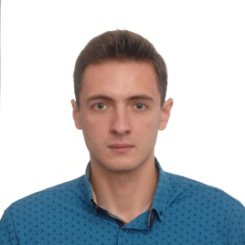
NAME | VITALI LITVINOVICH
ADDRESS | ZHOLTOVSKOGO AVE.1-18, PINSK, BELARUS
CELL PHONE | +375 44 5468206
E-MAIL | VITALIAS22@MAIL.RU
NATIONALITY | BYR
DATE OF BIRTH | 22.08.1994
WORKING EXPERIENCE:
RETAIL BANKING SPECIALIST JOINT STOCK COMPANY «SAVINGS BANK «BELARUSBANK» Dzerzhinskogo Ave, 18 Minsk, Belarus |  | August 2015 – Present
- accepting payments
- currency exchange operations
- operations with plastic cards
- work with deposits
- professional customer service
SELLER 4TH CATEGORY CJSC «YUNIFUD», Centralnaya Str. 23, Pinsk, Belarus |  | August 2013
- consultation of buyers
- merchandising
- sale non-food items
EDUCATION AND TRAINING  Polessky State University.  Dnieper flotilla Str., 23, 225710 Pinsk, Brest Region, Belarus  Economics Faculty.  Specialization: Economics and management of enterprise industry.  Qualification awarded: Master of Business Administration.  Polessky State University.  Dnieper flotilla Str., 23, 225710 Pinsk, Brest Region, Belarus  Economics Faculty.  Specialization: Economics and management of enterprise industry.  Qualification awarded: Econimist-manager  High School Diploma, High School №18, Pinsk, Belarus  Short courses «Retail services in the bank», Minsk, Belarus |  | September 2015– Present  September 2011– June 2015  September 2000 – June 2011  November 2015 – December 2015
PERSONAL SKILLS
- Tolerant and flexible to different situations.
- Highly responsible and reliable
- Interpersonal communication skills
- Sales ability
OTHER SKILLS  Languages:  Science:  Sport: |  | English (upper intermediate)  Diploma 13th Russian Olympiad of national economic development Russia, scientific work on the theme “Anti-monopoly policy of Russia”  Karate for about 10-11 years
INTERESTS
- Traveling
- Business
- Sport

