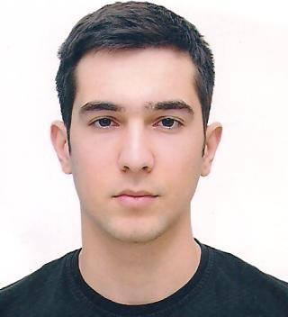
BAGHIROV Sanan

Mob.: +99450 368 6978;
E-mail: senan_bagirov@hotmail.com
Adr.: Azerbaijan, Baku, Z.Karimov str. 252; AZ1012.

Personal Information
Date and Place of Birth: 29.10.1991; Baku, Azerbaijan.
Military Status: State Border Service, July, 2013 - July, 2014.
Education
Azerbaijan Tourism Institute (Baku, Azerbaijan); Management (BA), September, 2009 - June, 2013.
Career History
- Coordinator; October 2015. France UEFA 2016 European CQ; Italy - Azerbaijan National teams home game.
- Professional Casting Coordinator ; August, 2015 - September, 2015.550th Anniversary of the Kazakh Statehood (Astana, Kazakhstan) ; Balich Worldwide Shows.
- Special Talent Coordinator; March, 2015 - July, 2015. Baku 2015 1st European Games; Five Currents;
- Coordinator (volunteer); November, 2012. 18th Azerbaijan International Exhibition and Conference, Telecommunications and Information Technologies (Azerbaijan, Baku);
- Coach; April, 2012 - September, 2012. Royal Beach Hotel ISROTEL Exclusive Collection (Israel, Eilat);
- Guest Service Representative; July, 2011 - September, 2011.Motel 6 Carowinds blvd (USA, South Caroline);
Computer and Language skills
- MS Office Programs (Word, Excel, Access, Power Point, Outlook); Windows operating system;
- Language knowledge: Azerbaijani (native), English (fluent), Russian (good), French (basic), Turkish (fluent).
Courses and Social Activities
- IMAN computer and IT courses, Office Programs (28.01.2010);
- AIESEC Azerbaijan member.

References:
Dr. Eldar Aslanov, Vice-Rector of Azerbaijan Tourism Institute;
Kimberley Tyler, General Manager of Motel 6 Carowinds blvd;
Lorenzo Gentile, Casting Director of Five Currents LLC; Baku 2015 Ceremonies
Catherine Archambault, Associate to Artistic Director; Baku 2015 Ceremonies

References available upon request.

