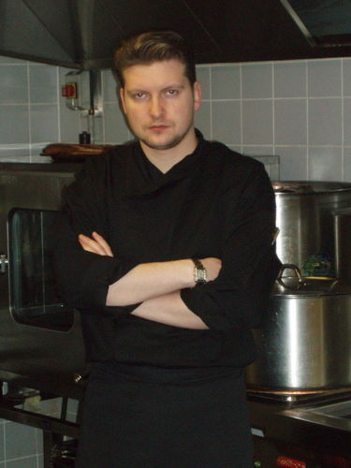

**Porvatkin Alexander**

Chef / the Brand chef  
34 years old (born 9 April 1982), male, University degree, not married  
Moscow   
Citizenship: Russia

Phone number: +7 (925) 723-63-32

E-mail: porvatkin@list.ru

**Experience:**

July 2016 – currently

Chef, Italian restaurant «The Che Bazza», city of Moscow

Optimization of the purchases of products, increasing the profitability of the menu, increase margins on food, the increase in the average check, training of kitchen staff.

April 2015 – May 2016  
Chef, restaurant "Esperanto", city of Grozny  
Menu development, training staff, optimising the consumption of products, work with staff

April 2013 – April 2015

NechaevGroup, Brand-chef restaurant chain, Rostov-on-don

Job responsibilities and achievements:

• Chief consultant, monitoring management and training of kitchen staff;

• The introduction of new, cost-effective organizational and technological processes for public catering;

• Development of process maps and control of the preparation of meals;

• Optimize the purchase of products;

• Recruitment and training of staff.

Optimization of the purchases of products, increasing the profitability of the menu, increase margins on food, the increase in the average check.

January 2011 — December 2012  
Brand chef Cooks "the Delicate Fresh", Moscow. Network caterers premium.

Job responsibilities and achievements:  
• Develop menus and technological cards;  
• Work with suppliers;  
• Quality control of food, the occupancy of storefronts;  
• Organization of kitchen work;  
• The introduction of new positions, seasonal festivals.  
Inferring the network of caterers from the crisis, eveliene sales.

January 2009 — December 2010  
Brand chef Crocus Expo, Moscow. Exhibition center Crocus Expo. [www.crocus-expo.ru](http://www.crocus-expo.ru/) .

Job responsibilities and achievements:  
• Work with suppliers;  
•Organization of events of more than 1,000 people;  
• Conducting individual events and celebrations, VIP service;  
• Work with staff.  
Opening a food court on 10 000 seats.  
  
January 2009 — December 2010  
Brand-chief of the sports Complex "Olympic", "Olympics 80", Moscow.

Job responsibilities and achievements:  
• Organization, control and strukturirovana kitchen work;  
• Training and coaching of staff;  
• Menu planning, commercial proposals for banquets, receptions;  
• Quality control of food, development of technological cards and compoundings of production;  
• Quality control of incoming raw materials, technology of cooking and serving meals, banquets, receptions, etc.  
• The organization of the service receptions and banquets after holding a concert in SC "Olympic".  
The increase in permeability of the restaurant 5 times.  
  
January 2007 — December 2008  
The brand-chef of the Sheremetyevo-1 Terminal, Moscow. The organization of the food court at the airport Sheremetyevo-1, Terminal S.  
Job responsibilities and achievements:  
• Work with suppliers;  
• Organization of staff training;  
• Organization of work of the court.

January 2005 — December 2006  
The brand-chef of Novikov Group (Black October, karaoke "October", "Porto Cervo", "delis"), Moscow. The organization of cafes, restaurants premium.  
Job responsibilities and achievements:  
• Introduction, development of author's dishes;  
• Develop catering events for groups from 250 to 800 people;  
• Development of seasonal menus, the "festival";  
• Work with suppliers;  
• Perfect organization and smooth operation of the kitchen.  
  
January 2002 — December 2004  
The chef of the Restaurant "Nevka", Moscow. A restaurant serving European cuisine.  
Job responsibilities and achievements:  
• Organization, control and strukturirovana kitchen work;  
• Training and coaching of staff;  
• Menu planning;  
• Order and stock items;  
• Organization of inventory;  
• Organization of trainings;  
• Development of quality control of food, technological cards and compoundings of production;  
• Monitoring the implementation of the rules and norms of labor protection, safety engineering, industrial hygiene and fire safety;  
• Quality control of incoming raw materials, technology of cooking and serving meals, banquets, receptions, etc.

**Skills and achievements:**1999 - gold medal at the Moscow championship of chefs in the category "Carving"  
2000 - the Mayor's Cup. First place in the category "Best chef of the city of Moscow. Stars cooking the third Millennium"  
2000 - the chefs Olympics in Germany. Represented Russia. Bronze medal.  
2001 - "the feast". Gold medal.  
2002 - member of Independent jury of the world Association of cooks.  
2003 - the Order "the Master chief" the Moscow Mayor.  
2004 - First prize at the Kremlin Cup  
2005 - the Judge of the championship of Eurasia. Ekaterinburg  
From 2005 to 2008 - member of the Board of judges of the interregional Association of cookery specialists  
From 2009 to 2011 - President of the Federation of workers of public catering.  
From 2011 to 2012 was trained by the personal chef of the king of Morocco Christian Maurino.  
In 2014 included in encyclopedia of successful people "Who Is Who in Russia".  
Author of training manuals.

Education: RATH, Moscow.  
Level of education: Incomplete higher.  
Faculty: Management and governance.  
Specialty: Hotel and restaurant business.  
Form of study: Day/full time.  
  
Moscow economic-technological College, Moscow.  
Level of education: post-Secondary education.  
Faculty: Technology of products of public catering.  
Profession: Engineer.  
Form of study: Day/full time.  
  
Courses and trainings: 2006 the Technology of preparation of Italian dishes. Italian culinary school "Serramazzoni", Moscow.